Image Text Component

**Page Reference** - <https://www.ancestry.com/corporate/>

**AEM URL** - <http://localhost:4502/content/ancestry-corp/us/en.html?wcmmode=disabled>

Properties Tab

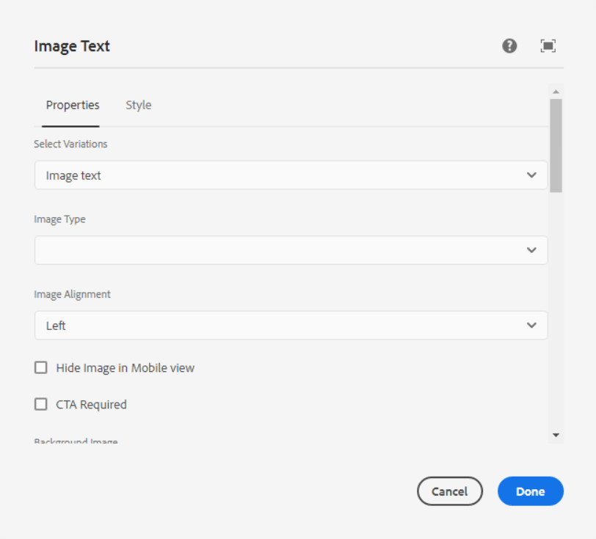

**Select Variations** - In this dropdown below list of variations are available, we can select one variation as per our requirement.

1. **Image Text**

Page Reference - <https://www.ancestry.com/corporate/>

AEM URL - [https://author-ancestry-dev2.adobecqms.net/content/ancestry-corp/us/en](https://author-ancestry-dev2.adobecqms.net/content/ancestry-corp/us/en/about-ancestry/our-team.html?wcmmode=disabled)[.html?wcmmode=disabled](http://localhost:4502/content/ancestry-corp/us/en.html?wcmmode=disabled)



1. **Blog Listing**

Page Reference - <https://www.ancestry.com/corporate/>

AEM URL - [https://author-ancestry-dev2.adobecqms.net/content/ancestry-corp/us/en](https://author-ancestry-dev2.adobecqms.net/content/ancestry-corp/us/en/about-ancestry/our-team.html?wcmmode=disabled)[.html?wcmmode=disabled](http://localhost:4502/content/ancestry-corp/us/en.html?wcmmode=disabled) - On the AEM page, the below design is covered by using a blog listing component but we can achieve it from an image text component also



1. **Testimonial**

Page Reference - <https://www.ancestry.com/corporate/corporate-responsibility>

AEM URL - <https://author-ancestry-dev2.adobecqms.net/content/ancestry-corp/us/en/corporate-responsibility.html?wcmmode=disabled>

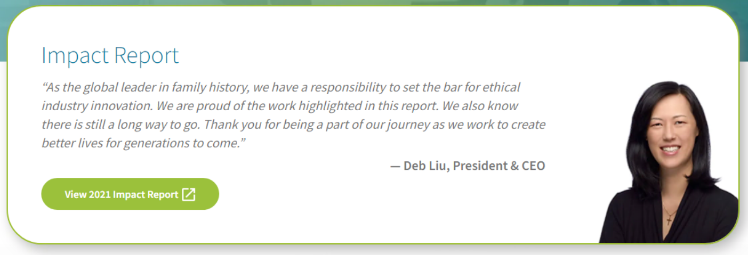

**Image Type** - In this dropdown below list of image types are available, we can select one type as per our requirement.

1. **Large Text**

Page Reference - <https://www.ancestry.com/corporate/corporate-sustainability>

AEM URL - <https://author-ancestry-dev2.adobecqms.net/content/ancestry-corp/us/en/corporate-sustainability.html?wcmmode=disabled>

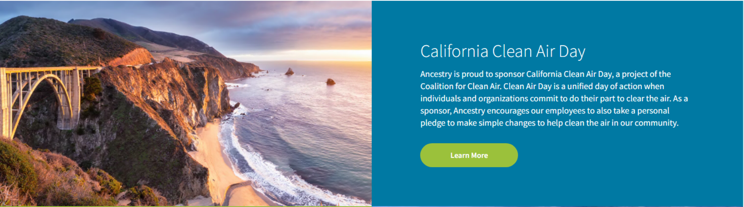

1. **No Background**

Page Reference - <https://www.ancestry.com/corporate/about-ancestry/our-story>

AEM URL - <https://author-ancestry-dev2.adobecqms.net/content/ancestry-corp/us/en/about-ancestry/our-story.html?wcmmode=disabled>

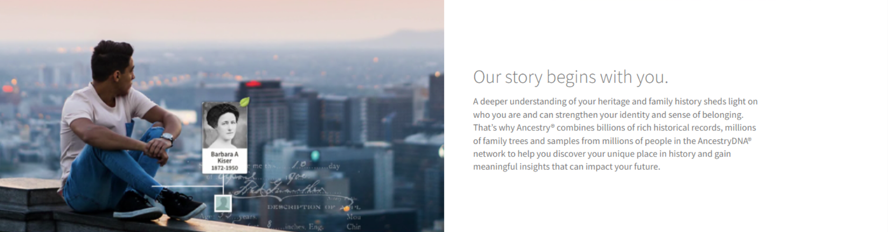

1. **Globe type (Static Image)**

Page Reference - <https://www.ancestry.com/corporate/>

AEM URL - [https://author-ancestry-dev2.adobecqms.net/content/ancestry-corp/us/en](https://author-ancestry-dev2.adobecqms.net/content/ancestry-corp/us/en/about-ancestry/our-team.html?wcmmode=disabled)[.html?wcmmode=disabled](http://localhost:4502/content/ancestry-corp/us/en.html?wcmmode=disabled)

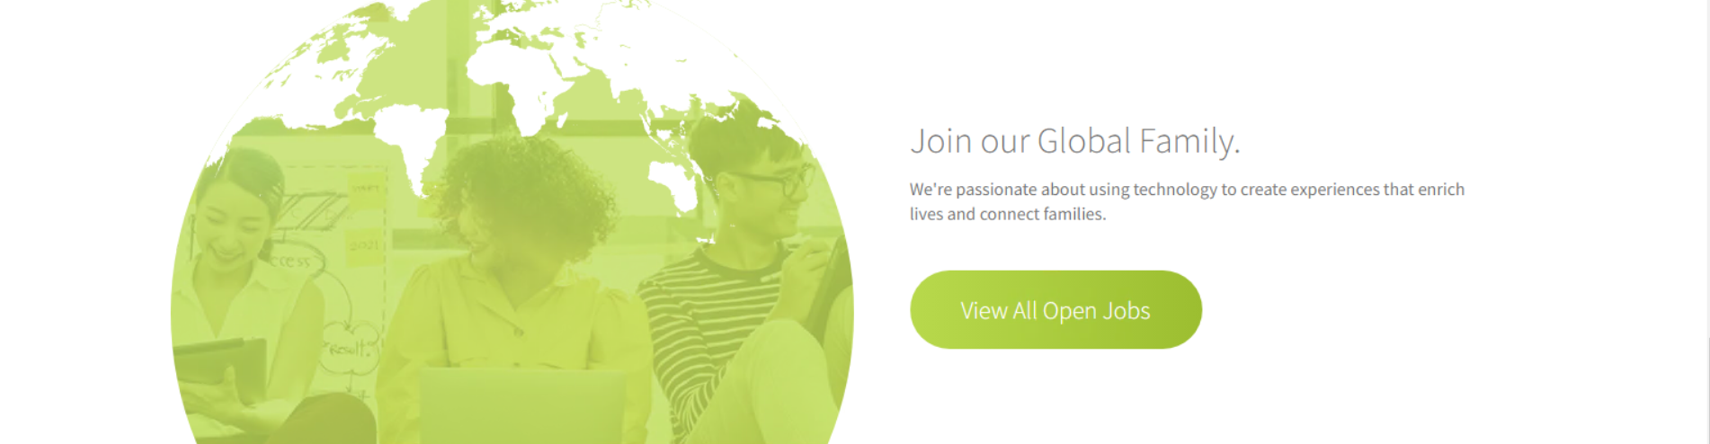

1. **Rounded Border Image No Background**

Page Reference - <https://www.ancestry.com/corporate/corporate-sustainability>

AEM URL - <https://author-ancestry-dev2.adobecqms.net/content/ancestry-corp/us/en/corporate-sustainability.html?wcmmode=disabled>

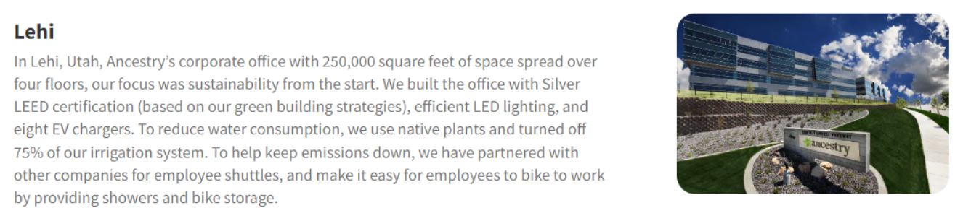

1. **Smaller Image (50% width) No Background**

Page Reference - <https://www.ancestry.com/corporate/corporate-sustainability>

AEM URL - <https://author-ancestry-dev2.adobecqms.net/content/ancestry-corp/us/en/corporate-sustainability.html?wcmmode=disabled>

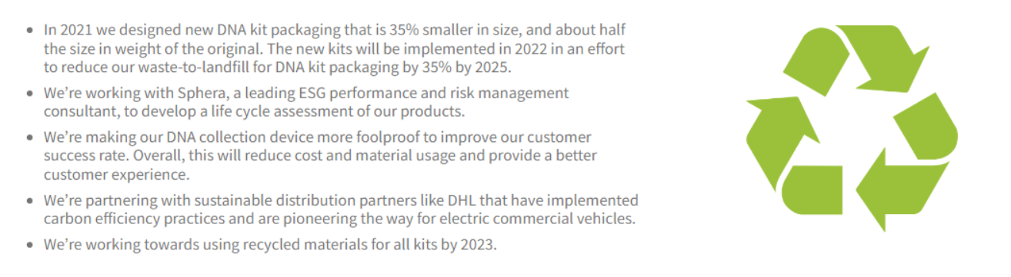

1. **Blog Type**

**Page Reference -** <https://www.ancestry.com/corporate/blog>

**AEM URL -** <https://author-ancestry-dev2.adobecqms.net/content/ancestry-corp/us/en/blog.html?wcmmode=disabled> - On the AEM page, the below design is covered by using a blog listing component but we can achieve it from an image text component also



**Image Alignment** - In this dropdown below list of image alignments are available, we can select one alignment as per our requirement.

1. **Left**
2. **Right**

**Checkbox for Hide image in Mobile View –** If Background image does not require in mobile then select this checkbox

**Checkbox for CTA Required –** If we require CTA after paragraph text then select this checkbox

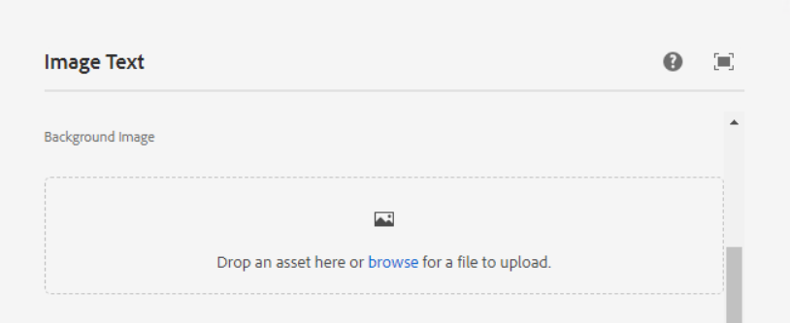

**Background Image** – Here we can edit, clear or pick any image as per the requirement.

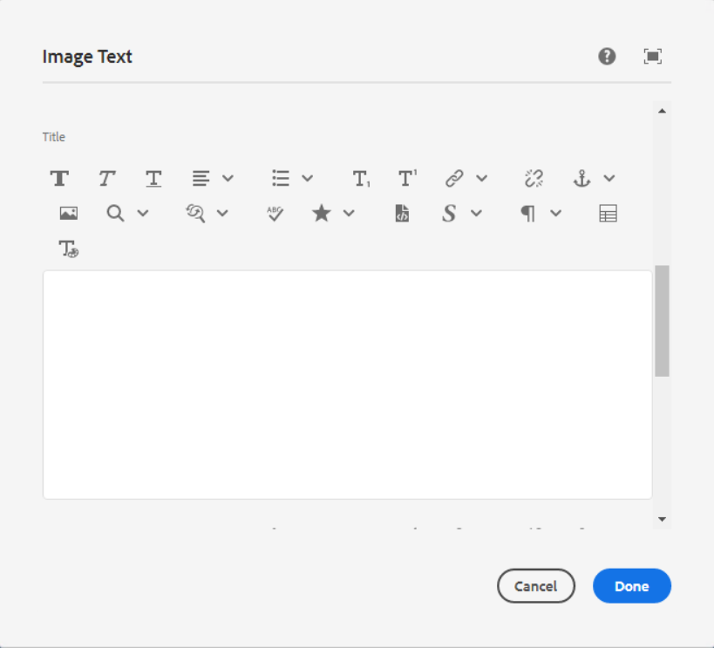

**Text** – In this field we can add title using RTE.

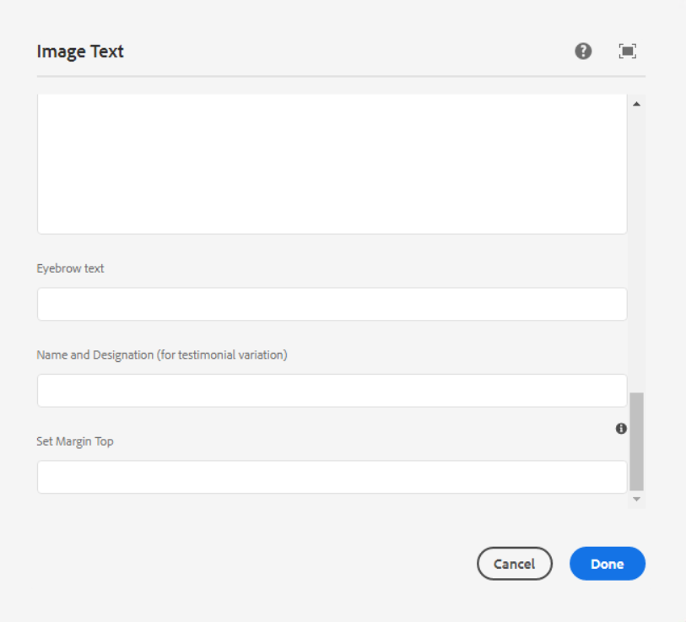

**Paragraph Text** – In this field we can add Paragraph Text using RTE.

**Name and Designation (For testimonial Variation) -** This is for Name and Designation value. (-Deb LIE, President & CEO)

Page Reference - <https://www.ancestry.com/corporate/corporate-responsibility>

AEM URL - <https://author-ancestry-dev2.adobecqms.net/content/ancestry-corp/us/en/corporate-responsibility.html?wcmmode=disabled>



**Eyebrow Text** – This is for sub-heading text

Page Reference - <https://www.ancestry.com/corporate/>

AEM URL - [https://author-ancestry-dev2.adobecqms.net/content/ancestry-corp/us/en](https://author-ancestry-dev2.adobecqms.net/content/ancestry-corp/us/en/about-ancestry/our-team.html?wcmmode=disabled)[.html?wcmmode=disabled](http://localhost:4502/content/ancestry-corp/us/en.html?wcmmode=disabled) - On the AEM page, the below design is covered by using a blog listing component but we can achieve it from an image text component also



**Set Margin Top** – We can set here margin-top value

Page Reference - <https://www.ancestry.com/corporate/corporate-responsibility>

AEM URL - <https://author-ancestry-dev2.adobecqms.net/content/ancestry-corp/us/en/corporate-responsibility.html?wcmmode=disabled>



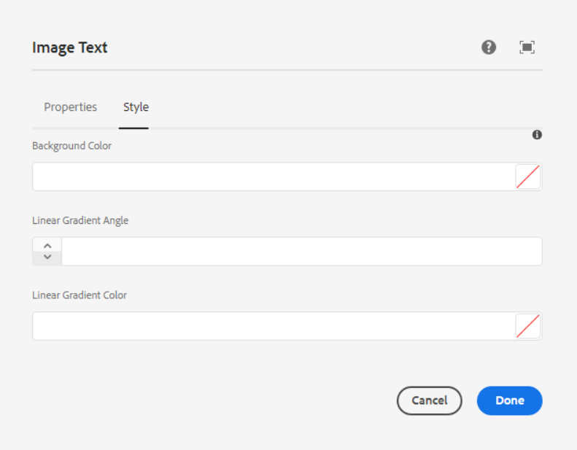

**Background Color** – Pick any color as per our requirement in hex or RGBA format.

**Linear Gradient Angle** – Here we can set the angle of the background Image

**Liner Gradient Color** – Here we have option to add color.

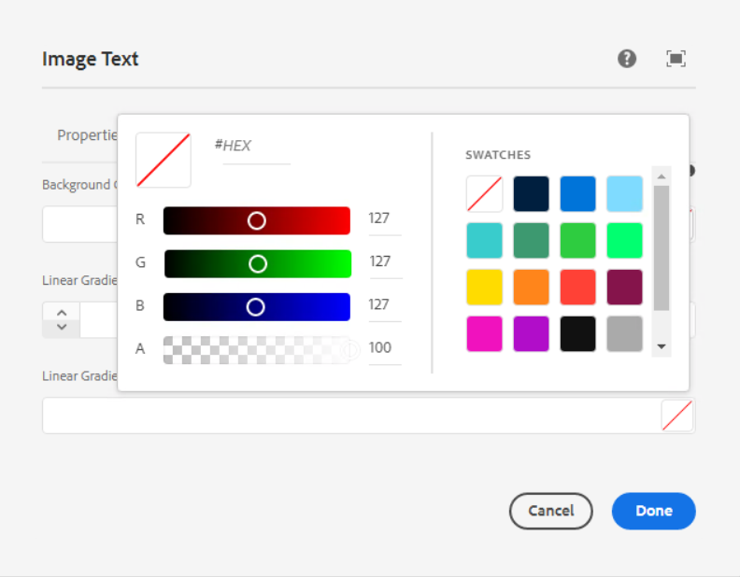

___________________________________________________________________

**Page References**

**Image right position with left side text**

<https://www.ancestry.com/corporate/blog/international-womens-day>

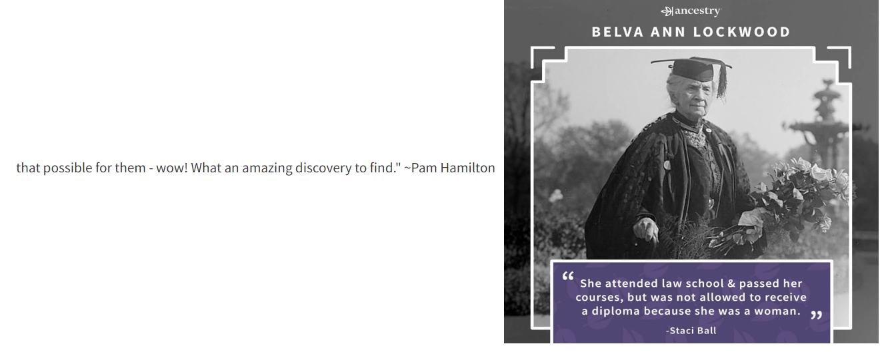

------------------------------------------------------------------------------------------------------------  
**Image left position with right side text**

<https://www.ancestry.com/corporate/blog/international-womens-day> 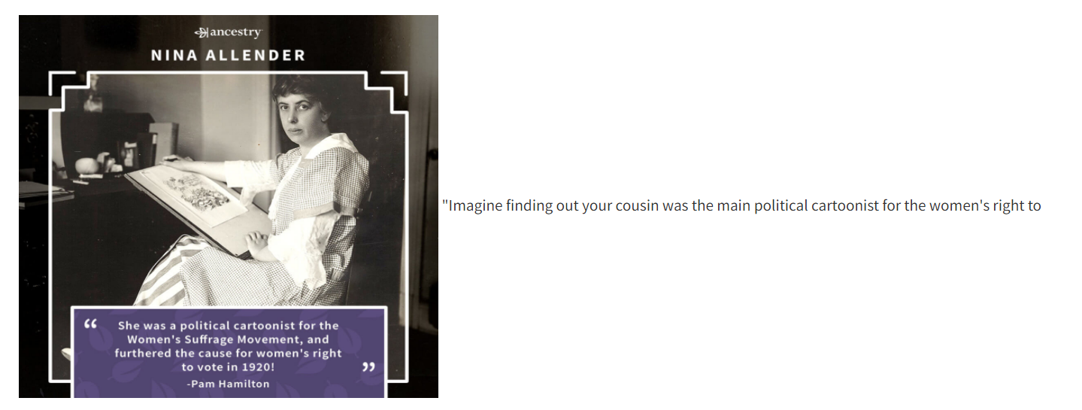

------------------------------------------------------------------------------------------------------------  
<https://www.ancestry.com/corporate/community-impact>

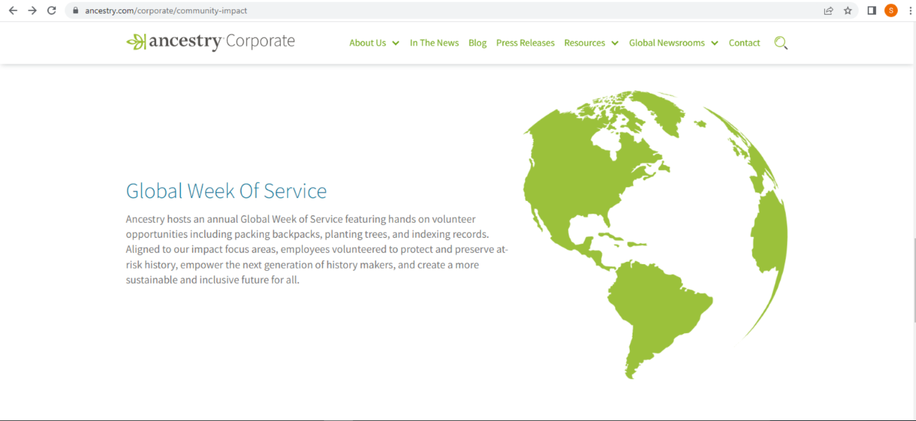

------------------------------------------------------------------------------------------------------------

<https://www.ancestry.com/corporate/about-ancestry/our-story>

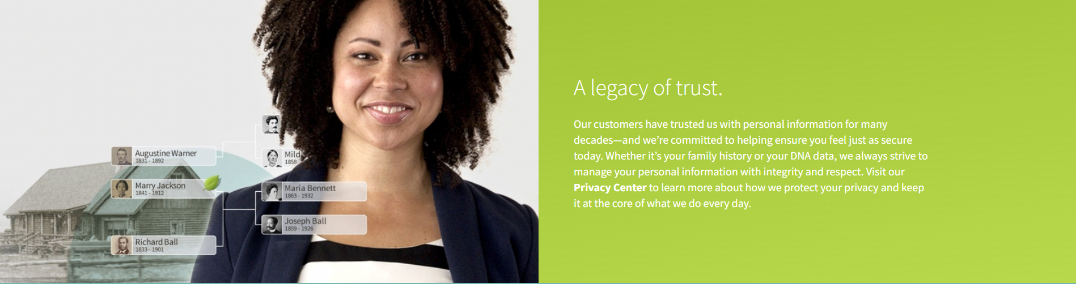

------------------------------------------------------------------------------------------------------------

<https://www.ancestry.com/corporate/au>

